Adaboost Algorithm :(it is stage wise & additive method)

1. It is boosting algorithm and it is part of ensemble learning. Morley it is pronounce by Weak learner (having less accuracy) and why we pronounce it, because after combination of weak learner we get big and powerful learner

(basically learn from mistake and improve in certain iteration). There different type of weak learner but here we discuss it more about one of its type decision stump it work like decision tree which have max_depth upto 1 and for classification of any input query we will use 1 and -1 (not 0like binary classification)

how we make split and how the given process will happen:-

so as from here we have dataset which have attribute like Cgpa,Iq and placement(target columns)

so as we do splitting in decision tree so here we will also split data point with the max_deapth =1(decision stump) and select the split having higher information gain, after that we have will scan remaining truly classified and misclassified some of classified point remains in decision stump while other are outside of stump ,so what learner we will do for the next decision stump they will increase the weightage(alpha) by up-sample technique for the true datapoint which doesn't lies in decision split(increase the weightage basically ) so we repeat all the process of splitting based on information gain and applying the increment of weightage for the true datapoint which doesn't lies in decision split .updating of previous process going on based on the no. of datapoints.

so after the no. of iterations of decision stump and their weightage we will sum by the given formula:

h(x)=sin (aplha_1* h1(x) + aplha_2 * h2(x) + aplha_3 * h3(x)....+alpha_n * hn(x)).

h1=hypothesis function and where x is input data point.

alpha is weightage. and sin function denote the positive and negative (weather student got placed or not) of data point after overall calculation alpha_n*hn(x) and so on

example if student having Cgpa 7.5 and Iq =80 so we have predict weather it got placed or not

so assume we have 3 model so h1(x) for 1 model it would be = -1

h2(x) for 2 model it would be = 1

h3(x) for 3 model it would be = -1

and let assume alpha(weightage for model) alpha_1 = 2

alpha_2 = 10

alpha_3 = 1

so h(x)=sin(aplha_1* h1(x) + aplha_2 * h2(x) + aplha_3 * h3(x))

h(x)=sin(2*(-1)+10(1)+1(-1)

so h(x) =0.6569(positive point)

so the student get placed

for more mathematical depth how alpha and h are calculated:

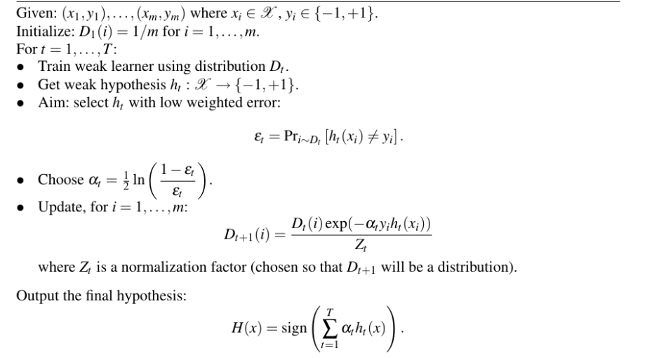

Reference link for above pic :-- <https://stackoverflow.com/questions/42604643/adaboost-algorithm-walkthrough-for-non-technical>